Labo 4 BDR

**-- Exercice 01**

drop trigger if exists payment_date;

DROP TRIGGER IF EXISTS trigEx1;

DELIMITER $$

create trigger trigEx1

before insert on payment

for each row

begin

set

NEW.amount = NEW.amount * 1.08,

NEW.last_update = NOW();

end; $$

DELIMITER ;

**-- END Exercice 01**

**-- Exercice 01_insert**

insert into payment(customer_id, staff_id, rental_id, amount, payment_date)

values (1, 1, 1, 1, now());

**-- END Exercice 01_insert**

**-- Exercice 01_affichage**

select

customer_id,

staff_id,

rental_id,

amount,

payment_date

from payment

where rental_id = 1;

**-- END Exercice 01_affichage**





**-- Exercice 02_a**

CREATE TABLE staff_creation_log (

username varchar(16) NOT NULL,

when_created TIMESTAMP NOT NULL

)ENGINE=InnoDB DEFAULT CHARSET=utf8;

**-- END Exercice 02_a**

**-- Exercice 02_b**

DROP TRIGGER IF EXISTS trigEx2;

DELIMITER $$

create trigger trigEx2

after insert on staff

for each row

begin

insert into staff_creation_log (username, when_created)

values (

NEW.username,

NEW.last_update

);

end; $$

DELIMITER ;

**-- END Exercice 02_b**

**-- Exercice 02_insert**

insert into staff(first_name, last_name, address_id, email, store_id, active, username, last_update)

values ("Jean", "Dupond", 5, "jean.dupond@gmail.com", 3, 1, "JDup", NOW());

**-- END Exercice 02_insert**

**-- Exercice 02_affichage**

select *

from staff_creation_log

where username = "JDup";

**-- END Exercice 02_affichage**



**-- Exercice 03**

DROP TRIGGER IF EXISTS trigEx3;

DELIMITER $$

create trigger trigEx3

before insert on staff

for each row

begin

set

NEW.email = concat(NEW.first_name, '.', New.last_name, '@sakilastaff.com');

end; $$

DELIMITER ;

**-- END Exercice 03**

**-- Exercice 03_insert**

insert into staff(first_name, last_name, address_id, email, store_id, active, username, last_update)

values ("Jean", "Dupond", 5, "jean.dupond@gmail.com", 3, 1, "JDup", NOW());

**-- END Exercice 03_insert**

**-- Exercice 03_affichage**

select

first_name,

last_name,

email

from staff

where username = "JDUP";

**-- END Exercice 03_affichage**



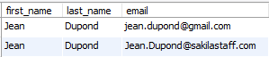

**-- Exercice 04_a**

DROP TABLE IF EXISTS customer_store_log;

create table customer_store_log(

customer_id int,

last_store_id int,

register_date DATE,

unregister_date DATE

)ENGINE=InnoDB DEFAULT CHARSET=utf8;

**-- END Exercice 04_a**

**-- Exercice 04_b**

DROP TRIGGER IF EXISTS trigEx4;

DELIMITER $$

create trigger trigEx4

before update on customer

for each row

begin

if OLD.store_id <> NEW.store_id

then

insert into customer_store_log(customer_id, last_store_id, register_date, unregister_date)

values(OLD.customer_id, OLD.store_id, OLD.last_update, now());

end if;

end;$$

DELIMITER ;

**-- END Exercice 04_b**

**-- Exercice 04_update**

update customer set store_id = 4 where customer_id = 1;

**-- END Exercice 04_update**

**-- Exercice 04_affichage**

select *

from customer_store_log

where customer_id = 1;

**-- END Exercice 04_affichage**



**-- Exercice 05**

set global event_scheduler = ON;

drop event if exists delete_row;

create event delete_row on schedule every 1 minute

on completion preserve

do

delete from customer_store_log

where customer_id in (

select

customer_id

from (

select

customer_id

from customer_store_log

group by customer_id

having

count(customer_id) > 1

and

max(unregister_date) < now() - interval 1 year

) as tab1

);

**-- END Exercice 05**

**-- Exercice 06_a**

drop view if exists vue_ex6;

create view vue_ex6

as

select

phone,

address

from staff

inner join address

on staff.address_id = address.address_id;

**-- END Exercice 06_a**

**-- Exercice 06_a_affichage**

select *

from vue_ex6

limit 20;

**-- END Exercice 06_a_affichage**

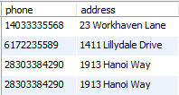

**-- Exercice 06_b**

Oui Franklin pourra mettre à jour la base de donnée à travers cette vue car elle ne contient aucune des catégories bloquant les vues updatables :

pas de fonction d'aggregation, ni de distinct, ni de group by, ni de having, union, sous-requête dans un select, sous-requête dans un where, etc..

update vue_ex6 set phone = '4' where phone = '14033335568';

**-- END Exercice 06_b**

**-- Exercice 06_b_affichage**

select

address,

phone

from address

where address_id = 3;

**-- END Exercice 06_b_affichage**





**-- Exercice 07**

drop view if exists vue_ex7;

create view vue_ex7

as

select

email,

film.title as 'titre',

datediff(NOW(), rental.rental_date + interval film.rental_duration day) as 'jours_retard'

from rental

inner join customer

on rental.customer_id = customer.customer_id

inner join inventory

on rental.inventory_id = inventory.inventory_id

inner join film

on inventory.film_id = film.film_id

where rental.return_date is null

having jours_retard > 0;

**-- END Exercice 07**

**-- Exercice 07_affichage**

select *

from vue_ex7

limit 20;

**-- END Exercice 07_affichage**

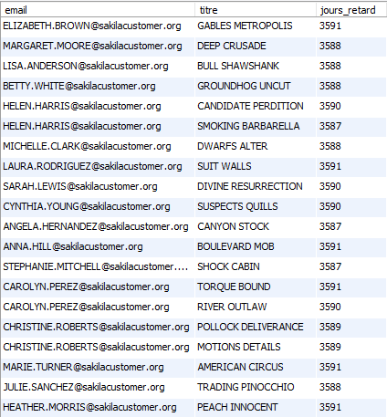

**-- Exercice 08**

select *

from vue_ex7

where jours_retard > 3

limit 20;

**-- END Exercice 08**

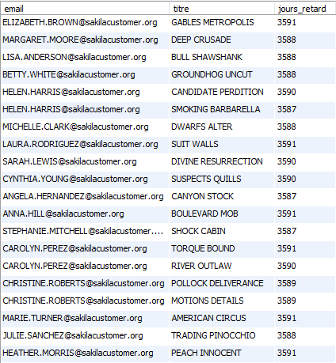

**-- Exercice 09_a**

drop view if exists vue_ex9;

create view vue_ex9

as

select

customer.first_name as 'prénom',

customer.last_name as 'nom',

customer.customer_id as 'id',

count(*) as 'nombre_locations'

from rental

inner join customer

on rental.customer_id = customer.customer_id

group by customer.customer_id;

**-- END Exercice 09_a**

**-- Exercice 09_a_affichage**

select *

from vue_ex9

limit 20;

**-- END Exercice 09_a_affichage**

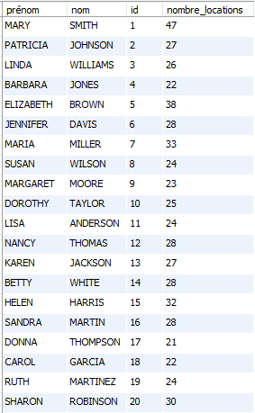

**-- Exercice 09_b**

select

prénom,

nom,

id,

max(nombre_locations) as nombre_locations

from vue_ex9

limit 20;

**-- END Exercice 09_b**



**-- Exercice 10_a**

drop view if exists vue_ex10;

create view vue_ex10

as

select

DATE(rental_date) as jour_location,

count(*) as nombre

from rental

group by jour_location;

**-- END Exercice 10_a**

**-- Exercice 10_a_affichage**

select *

from vue_ex10

limit 20;

**-- END Exercice 10_a_affichage**

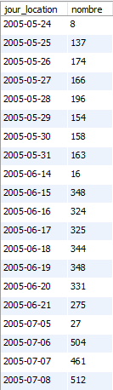

**-- Exercice 10_b**

select *

from vue_ex10

where jour_location = "2005-08-01";

**-- END Exercice 10_b**



**-- Exercice 11_a**

drop function if exists func_ex11;

delimiter //

create function func_ex11 (id_store int)

returns int

begin

declare nombre int;

select

count(*)

into nombre

from (

select distinct

film_id

from

inventory

where

store_id = id_store

) as a;

return nombre;

end; //

delimiter ;

**-- END Exercice 11_a**

**-- Exercice 11_b**

select

func_ex11(1) as nombre_films_store_1,

func_ex11(2) as nombre_films_store_2;

**-- END Exercice 11_b**



**-- Exercice 12_a**

drop function if exists func_ex12;

delimiter //

create function func_ex12 (id_store int)

returns int

begin

declare nombre int;

select

count(*)

into nombre

from

customer

where

store_id = id_store;

return nombre;

end; //

delimiter ;

**-- END Exercice 12_a**

**-- Exercice 12_b**

select

func_ex12(1) as nombre_clients_store_1,

func_ex12(2) as nombre_clients_store_2;

**-- END Exercice 12_b**



**-- Exercice 13_a**

drop function if exists func_ex13;

delimiter //

create function func_ex13 (id_store int)

returns double

begin

declare montant double;

select

sum(amount)

into montant

from

payment

inner join

staff

on

payment.staff_id = staff.staff_id

where

staff.store_id = id_store;

return montant;

end; //

delimiter ;

**-- END Exercice 13_a**

**-- Exercice 13_b**

select

func_ex13(1) as revenu_total_store_1,

func_ex13(2) as revenu_total_store_2;

**-- END Exercice 13_b**



**-- Exercice 14_a**

drop procedure if exists proc_ex14;

delimiter //

create procedure proc_ex14 ()

begin

update film

set last_update = NOW();

end; //

delimiter ;

**-- END Exercice 14_a**

**-- Exercice 14_b**

call proc_ex14();

select

film_id,

title,

last_update

from film

limit 20;

**-- END Exercice 14_b**

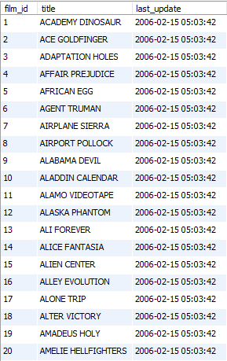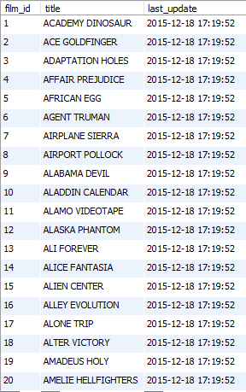

**-- Exercice 15_a**

drop procedure if exists proc_ex15;

delimiter //

create procedure proc_ex15 (

in id_store int,

out nombre_locations int,

out nombre_exemplaires int)

begin

select

count(rental_id)

into nombre_locations

from

rental

inner join

inventory

on

rental.inventory_id = inventory.inventory_id

where

store_id = id_store;

select

count(inventory_id)

into nombre_exemplaires

from

inventory

where

store_id = id_store;

end; //

delimiter ;

**-- END Exercice 15_a**

**-- Exercice 15_b**

call proc_ex15(1,@nombre_locations, @nombre_exemplaires);

select

@nombre_locations,

@nombre_exemplaires;

**-- END Exercice 15_b**

